[Polygon ID API Verification](https://www.postman.com/dark-star-200015/workspace/public/overview)

Step 1: - Import Polygon Id postman collection into postman.

<https://www.postman.com/dark-star-200015/workspace/public/overview>

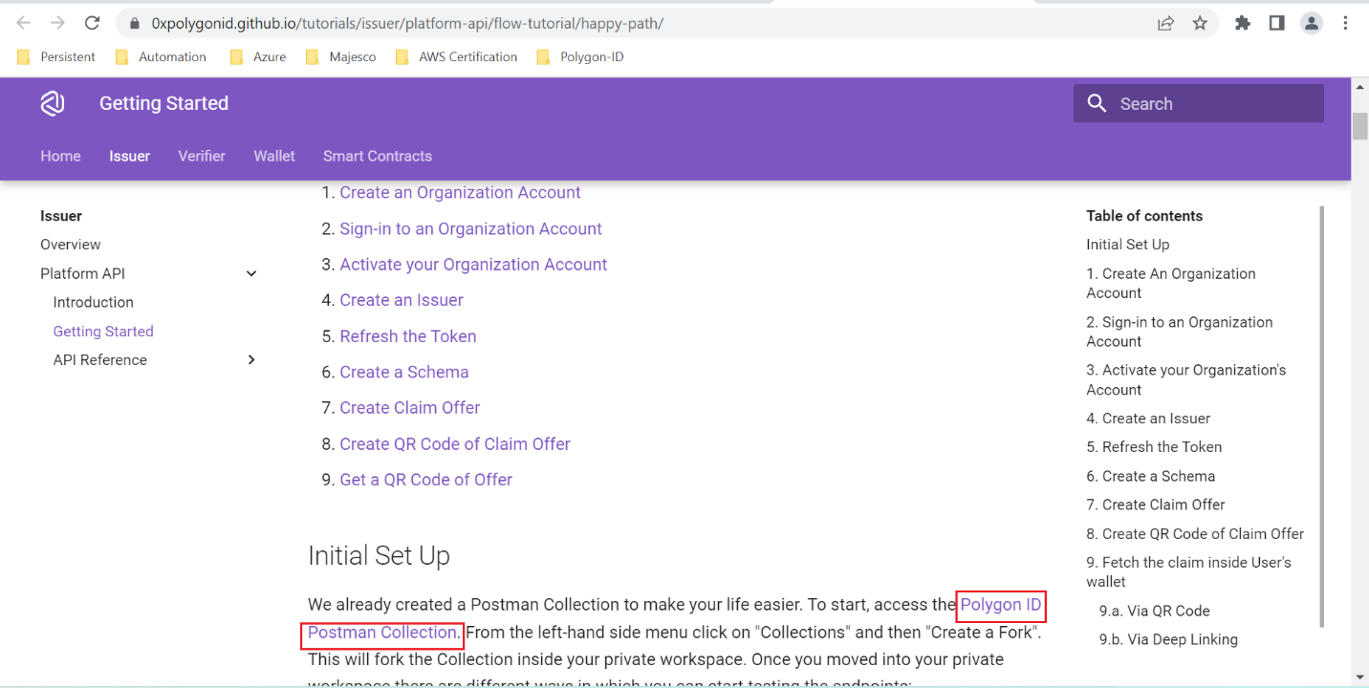

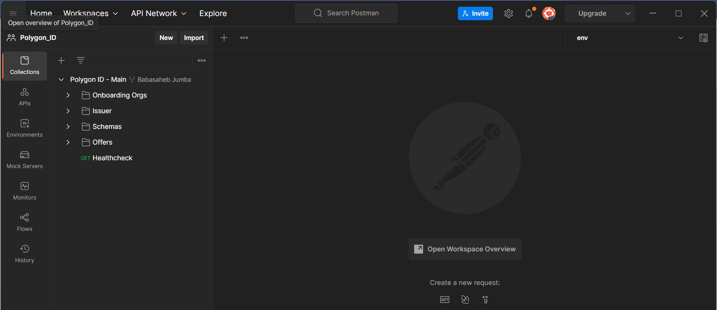

## Step 2: - Create an Organization Account

Select Create org and send request and verify the response.

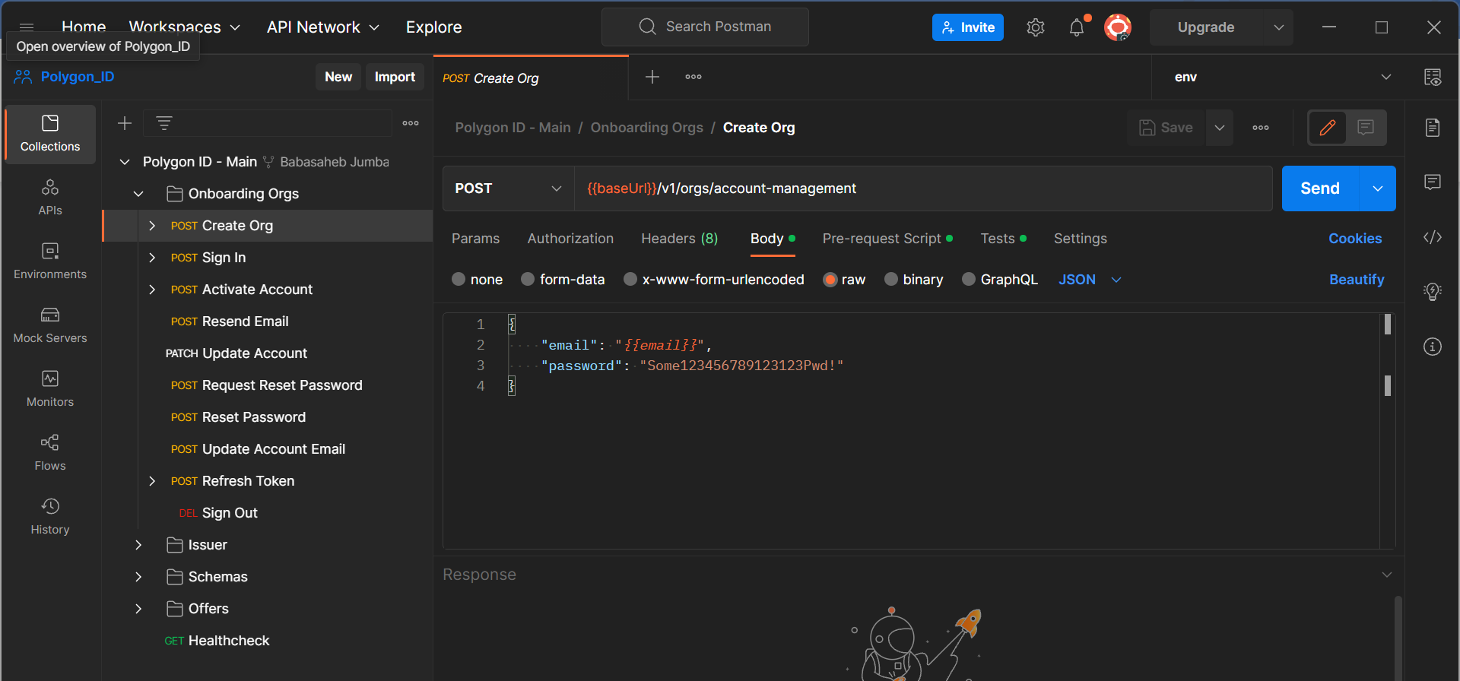

201 responses got successfully.

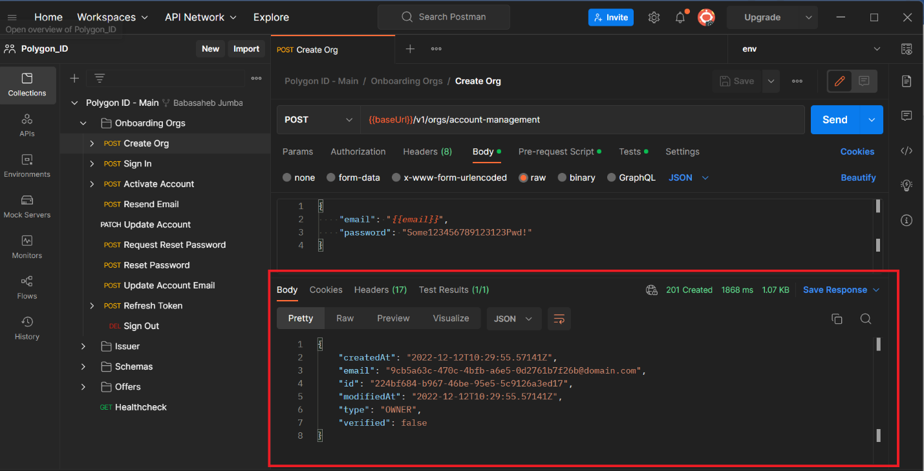

## Step 3: - Sign-in to an Organization Account

Select Sign In request and send request and verify the response.

## 

200 responses code receive.

Token got generated.

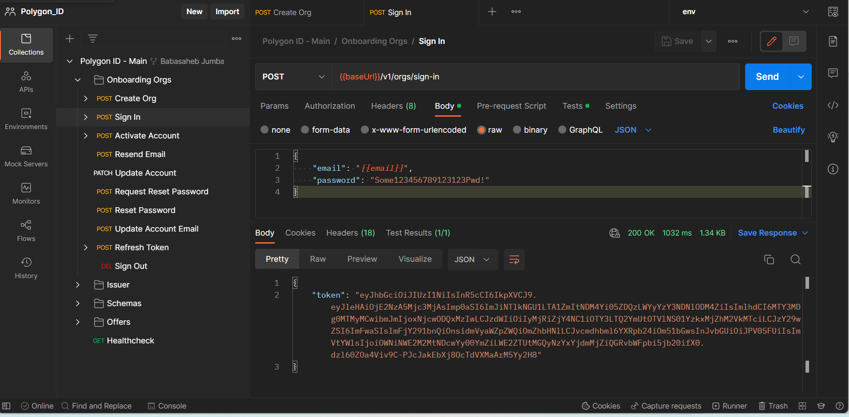

## Step 4: - Activate your Organization's Account.

Select Activate Account request and send request and verify the response.

For Authorization need to provide token which created during sign-in request.

## 

## Organization Account has been activated.

## 

## Step 5: - Create an Issuer

Select Create Issuer request and send request and verify the response.

## 

## Issuer Created Successfully.

## Issuer id: - "a085f8fd-c904-474e-a059-f6050427675c"

## 

## Step 6: - Refresh the Token

Select Refresh Token request and send request and verify the response.

## 

Token gets updated.

## 

## Step 7: - Create a Schema

Select Create Schema request and send request and verify the response.

Provide Issuer id on parameter.

## 

## Create Schema created successfully.

## 

## Schema id": "ea0e8790-8617-4770-b7d5-a1f5fed71a63

## 

## Step 8: - Create Claim Offer

Select Create Claim Offer request and send request and verify the response.

Provide IssuerID and schemaID on parameter.

## 

## Offer created successfully.

## 

## Offer id: a817b53c-fb40-4cca-973b-4e1f7900cb56

## 

## Step 9: - Create QR Code of Claim Offer

Select Create QR Code of Claim Offer request and send request and verify the response.

Provide Offer id parameter.

## 

## 

## 

## 

## 

## Step 10: - Fetch the claim inside User's wallet

### Get QRCode of Offer

## 

## 

## Download QRCode of Offer.

## 

## 

## Scan QR Code on mobile and verify offer.

## 

## 

## 

## 